Heinrich Hertz Technical Paper 2020

By James Duffy (17206286) and Eoin Flynn (15179818)

University of Limerick
E-mail: 17206286@studentmail.ul.ie
15179818@studentmail.ul.ie

ABSTRACT

Put your abstract here… It should be concise, no more than 300 words.
Before the abstract, the authors’ names should be centered below the title and should be in Time New Roman 12 points. The address should be centered below the author’s name and should be in Time New Roman 10 points. Please include your E-mail address. The initial title should be centered across the top of the first page and should be in Time New Roman Bold 18 points.

I. Introduction

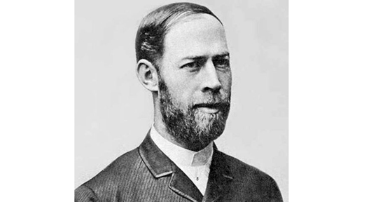

Figure 1.1 – Heinrich Hertz
Heinrich Rudolf Hertz was born in February 22, 1857 in Hamburg and died January 1, 1894. He showed that the Scottish physicist James Clerk Maxawell’s studies and theory on electromagnetism was indeed correct, proving that light and heat are forms of electromagnetic radiation.

II. Background

A. Subsection Title

Provide figures with their captions within the text. All illustrations and pictures should be high-contrast black and white (not color) prints.
References should be cited, at the end of the paper, in numerical order in which they appear in the text. When citing reference in the text, type the corresponding number in square brackets as shown at the end of this sentence: [1]. References should be complete and in standard IEEE style.

B. Instructions for 8 ½’’ x 11’’ paper :

The distance from the top edge of the paper to the top of the first line (i.e., the title) should be 23 mm. Left and right margins should be the same (19 mm). The width of each column should be 84 mm. The distance between the two columns of the text should be 10 mm. The distance from the bottom edge of the paper to the bottom of the last line of type on all page should be no less than 20 mm ; this allows room to insert the copyright notice and page numbers in the final version.

C. Instructions for A4 paper:

The distance from the top edge of the paper to the top of the first line (i.e., the title) should be 30 mm. Left and right margins should be the same (16 mm). The width of each column should be 84 mm. The distance between the two columns of the text should be 10 mm. The distance from the bottom edge of the paper to the bottom of the last line of type on all page should be no less than 26 mm ; this allows room to insert the copyright notice and page numbers in the final version.

III. Influences
IV. Technological Achievements
V. Impact And Applications

X. CONCLUSIONS

The conclusions of your paper. Future work directly from the paper is also acceptable.
This Word template for A4 pages has already defined styles for use in the paper.

REFERENCES

[1] A.B. Author, Book Title, New York: IEEE Press, ch. 6, pp. 23-35.
[2] C.D. Author, "Paper Title", Journal, vol. 8, 1997, pp. 1-10.
[3] E.F. Author, "Paper Title", in Proceedings of Conference, 1996, pp. 30 -34.

